**ELDO CG** 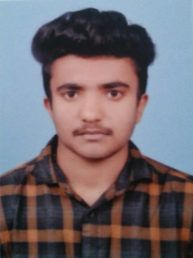

**CONTACT**

MAIL ID : eldocgeorge37@gmail.com

PHONE : **9486725837**

**CAREER OBJECTIVE**

To pursue a challenging career and be a part of progressive organization that gives a scope

to enhance my knowledge and utilizing my skills towards the growth of the organization.

**EDUCATION**

|  |  |  |  |  |
| --- | --- | --- | --- | --- |
| **DEGREE** | **COURSE** | **COLLEGE /**  **SCHOOL** | **PERCENTAGE** | **YEAR OF**  **PASSING** |
| Diploma | Instrumentation  And Control  Engineering | Govt Polytechnic  College Ooty | 70% | 2018 |
| HSC(+2) | Maths Computer | GHSS  Ambalamoola | 75.4% | 2016 |
| SSLC | _ | GHS Kayyunni | 76.2% | 2014 |

**ADDRESS** **:**  S/o GEORGE CY

**PERSONAL DETAILS**

5/195a, Chirappattu (HOUSE)

Kayyunni (PO), Kallichal

The Nilgiris, Tamilnadu

643205 (PIN)

**DATE OF BIRTH :** 29/07/1999

**GENDER :** Male

**MARITAL STATUS :** Single

**LANGUAGE KNOWN :**  English, Malayalam, Tamil

**PROJECT**

**TITLE :** PLC BASED BOILER CONTROL SYSTEM

**DETAILS :** PLC based boiler control system is a autonomous system used to monitor

the temperature and pressure of the boiler and switch ON/OFF the

corresponding cutoff relay, where safety valve relay opens when the

pressure exceeds the threshold value and boiler cutoff relay will be

activated then the temperature of the boiler exceeds the predefined

threshold value.

**PERSONAL STRENGTH**

1. Punctual, loyal and enthusiastic towards my work
2. Strive to achieve all goals common for the success of the organization

**QUALITIES**

1. Hard Worker
2. Good inter-relationship

**SKILLS**

1. Communication
2. Ability to work under pressure
3. Decision making
4. Time management
5. Self-motivation

**DECLARATION**

The above given details are true to the best of my knowledge.