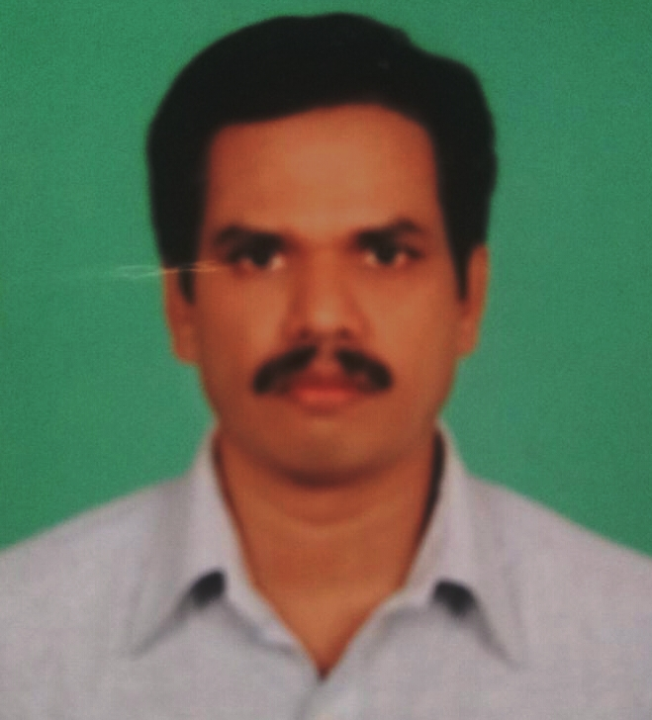
ANIL KUMAR.N.K

Nadukkandiyil House
Rayarangoth Post
Pin:673102
9497345756

ANIL KUMAR.N.K

Career Objective
Fervent of pursuing a career in a reputed organization where I can exploit my potential and interpersonal skills to the maximum.

Academic Qualifications
Year | Examination | Institute/University
1989 | M.com | Kerala University
1987 | B.com | Calicut University
1984 | Pre-Degree | Calicut University
1982 | S.S.L.C | Board of Public examination- Kerala State

COMPUTER / TECHNICAL KNOWLEDGE
Diploma In System Management | APPLE INDUSTRIES
Typewriting -English | Technical Education – Kerala State
 | Good working experience in MS-OFFICE & TALLY

Personal Details
Date of Birth | : | 27th May 1967
Permanent Address | : | Nadukkandiyil House  Rayarangoth Post  Madappally College. Via  Kozhikkode District  Vatakara - 673102
Father’s Name | : | Late. Balakrishna Kurup.N.V
Sex | : | Male
Religion | : | Hindu
Marital Status | : | Married
Languages Known | : | English, Hindi & Malayalam
Contact Number  Email | :  : | +91-9497345756 / 0496-2514737  anilggl@gmail.com

Professional Experience

Abroad

From 2016 -2018- QATAR

Worked as Store in Charge : Arabian M.E.P. Contracting Co. (AL MALKI GROUP) Mechanical, Electrical and Plumbing contracting Co.

From 1996 -2000 – BAHRAIN

Designation: Admn. Dept. & Accounts Assistant : Public Works Contracting Company. Area of works includes all correspondence relating to various public and private organisations, Procurements of materials for ongoing projects by inviting quotations and comparison of rates, preparation of payment vouchers to Vendors considering their credit limits and followup recievables, L.P.O.preparation.

India

From 2003 to 2010

Designation: Manager
ACE FINLEASE (P)Ltd. – A well reputed NBFC- regd. under R.B.I. (Vehicle Loan Financing Company) - in Calicut District. -

Responsible for loan disbursement after scrutinizing the customer profile, securitisation process with M/s.Sundaram Finance ltd., Tripartite agreement with Nationalised bank -INDIAN OVERSEAS BANK- for vehicle loans, Laisoning of Various Public and Private authorities for Financial Services approval- vehicle loans,Monitoring collection, fund flow, outstanding and its collection, Final settlement of normal and pending customers.Introduction of various schemes for boosting vehicle loans through vehicle showroom.

From 2011 to 2016 :

Designation:-Branch Manager :

ACE MOTORS (P)LTD- Vatakara -responsible for Sales, Service and Spares of Piaggio 3 wheelers & Hero Two wheelers,-authorised dealership of Piaggio and Hero vehicles- apart from this responsible for vehicle finance activities of ACE FINLEASE (P)Ltd., at Vatakara

Leading a team, includes sales , service,spares both Piaggio 3 wheel and Hero two wheel. Fixing monthly Sales Target,Conducting Demos and other marketing activities, monitoring & review the prefixed activities and performance of field executives and take effective measures for achieving their required targets. Negotiating with Nationalised banks and other private firms for bulk orders.

Declaration
I hereby declare that the above-furnished details are true to the best of my knowledge.
Anil Kumar. N.K

