RESUME
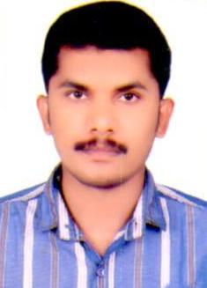
DILEESH KUMAR CP
Contact No. 0091-7025815217
Email:dileeshakns@gmail.com

CAREER OBJECTIVE

To build successful career with a professional managed company this will enhance my talent, knowledge and experience for personal and organizational growth.

EDUCATIONAL QUALIFICATION

- SSLC from Kerala Secondary board of Education in India.

- Computer Skills :MS Office all packages.

- Data entry Internet & Email.

JOB PROFILE

UAE Experience –School Transport Services

- 5 years as a Office Assistant Al Khaleej National School (GEMS School )
- 4 years experience as a School bus driver Al Khaleej National School (GEMS School )
- 6 years experience as a Customer Care Executive in School Transport Service (STS) Dubai

CERTIFICATE IS AWARD FROM GEMS

- Employee of the term school year 2004-2005
- Certificate of English Language programme year 2015
- Certificate of Best CCE Assistant year 2017
- Certificate of Long year Service (16 years GEMS GROUP) year 2002 - 2018

PERSONEL PROFILE

Date of Birth : 05/01/1982
Nationality : Indian
Gender : Male
Marital Status : Married
Language Proficiency : English, Hindi, Malayalam & Tamil
Passport No : K 2061724
Visa Status : Nil

LICENSE DETAILS

- UAE License No : 853869
- RTA Permit No. : 853869
- Vehicle Permitted : Light Vehicle, Light Bus & Heavy Bus

DECLARATION

I hereby declare that information gives above are true and correct to the best of my knowledge and belief.

DILEESH KUMAR CP
Mobile : 0091-7025815217

