**RESUME**

**JEYSHIN.N** 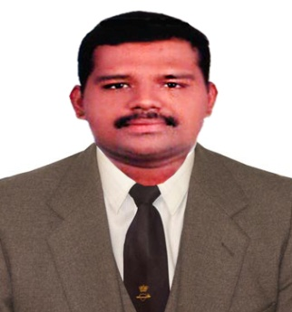

NERAVATH HOUSE

PALATH (P.O)

KAKKODI (VIA)

CALICUT - 673611

PH: +91 8129546551

EMAIL ID: [jeyshinjay@gmail.com](mailto:jeyshinjay@gmail.com)

PASSPORT NUMBER: J9640857

**PERSONAL DETAILS**

FATHER’S NAME : VIJAYAN.N

DATE OF BIRTH : 03-05-1989

NATIONALITY : INDIAN

MARITAL STATUS : MARRIED

RELIGION & CASTE : HINDU, THIYYA

LANGUAGES KNOWN : MALAYALAM, ENGLISH, HINDI, AND ARABIC

DRIVING LIC DETAILS : HOLD VALID 2/3/4 DRIVING LICENCE

**OBJECTIVE:**

To be a part of an organization that could utilize my knowledge and skill for the growth and expansion of the organization and thereby contributing to mutual growth.

**QUALIFICATION**

|  |  |  |  |
| --- | --- | --- | --- |
| **COURSE DETAILS** | **BOARD OF**  **UNIVERSITY** | **%**  **MARK** | **NAME OF**  **INSTITUTION** |
| **AUTOMOBILE ENGINEERING** | **KGCE-NCVT** | **80** | **ETI THAMARASSERRY** |
| **PLUS TWO** | **BOARD OF**  **HIGHER SECONDARY**  **EDUCATION KERALA** | **78** | **SN COLLEGE CHELANNUR CALICUT** |

**ADDITIONAL QUALIFICATION**

* COMPUTER KNOWLEDGE
* MS OFFICE
* TOYOTA MASTER TECHNICIAN TRAINING PASSED
* TOYOTA HYBRID SYSTEM TRAINING ATTENTED
* WORK EXPERIENCE IN JAPANEES AND AMERICAN CARS
* CUSTOMER HANDLING
* SOLVE CUSTOMER COMPLAINTS
* SERVICE CENTER MANGEMENT
* TRACKING ALL SERVICE RELATED WORKS

**EXPERIENCE TOTAL 9 YEARS AND 6 MOTHS**

|  |  |  |
| --- | --- | --- |
| **ORGANISATION NAME** | **DURATION** | **ROLE** |
| KOYENCO MOTORS (TATA DEALER KERALA) | JANUARY 2009 TO JANUARY 2010 | TECHNICIAN |
| AMANA TOYOTA (TOYOTA DEALER KERALA) | APRIL 2010 TO APRIL 2012 | TECHNICIAN |
| SAUD BAHWAN AUTO MOTIVE LLC  (TOYOTA DEALER OMAN) | MAY 2012 TO OCTOBER 2016 | TECHNICIAN /CUSTOMER COMPLAINT CORDINATOR |
| AM MOTORS MARUTI SUZUKI  (MARUTI SUZUKI DEALER KERALA) | JANUARY 2017 (PRESENTLY WORKING) | CUSTOMER COMPLAINT CORDINATOR |

**DECLARATION**

I HERE BY DECLARE THAT THE ENTRIES ARE CORRECT TO THE BEST OF MY KNOWLEDGE AND BELIEF.

PLACE: KOZHIKODE

DATE :  **JEYSHIN.N**