**RESUME**

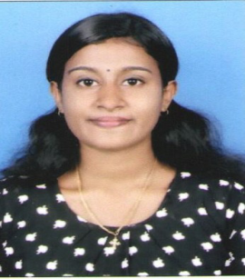 **AJINA M KUNJACHAN**

Mob: 7034227500

Email id: [ajina6268@gmail.com](mailto:ajina6268@gmail.com)

**MUTTATHU (HO)**

**KARACHAL (P.O)**

**MEENANGADI**

**WAYANAD-673579**

**OBJECTIVE**

**“To attend the growth oriented and respectable career position, which gives good professional status with a well, established and reputed organization.”**

**ACADEMIC QUALIFICATION**

|  |  |  |
| --- | --- | --- |
| **COURSE** | **BORD /UNIVERSITTY** | **YEAR** |
| **S.S.L.C** | **Kerala State Board** | **2011** |
| **PLUS TWO** | **Kerala State Higher Secondary Board** | **2013** |
| **BA HISTORY** | **Calicut university** | **2017** |
| **ITES** | **AVON FMS kalpetta** | **2017** |

**TECHNICAL EXPOSURE**

 

* MS Word
* MS Excel
* Handling Email Accounts
* MS Power point
* DMS (dealer management system **MARUTI SUZUKI**

**LANGUAGES KNOWN**

* Malayalam : Read,Write,Speak
* English : Read,Write,Speak
* Hindi : Read,Write
* Tamil : Speak

**WORK EXPERIENCE**

* 6 Month Experience in customer care executive (Popular vehicles & service, Maruti Suzuki)
* 6 Month Experience in customer care executive (Maijo Motors, Maruti Suzuki)
* 2 Year Experience in customer care executive (Indus motor CO.PVT LTD, Maruti Suzuki)

**PERSONAL DETAILS**

Age : 24

Date of birth : 27-2-1996

Martial details : Single

Nationality : Indian

Religion : Christian

**DECLARATION**

I hereby declare that the particulars given above are true and correct to the best of my knowledge and belief.

Place:

Date :

AJINA M KUNJACHAN