CURRICULUM VITAE

CAREER OBJECTIVE:
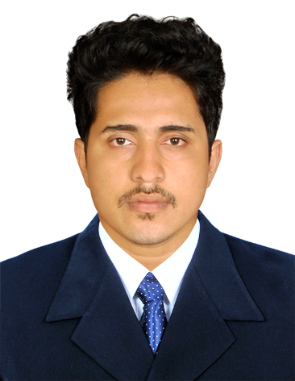

SREEJESH.A
Mob: +91 8921433779

EMAIL ID: sreejesha2@gmail.com

ADDRESS

Arouth house
Chettikulam, Elathur( PO)
Calicut, Kerala, India-673303

PERSONAL DETAILS

Name of Father: Vijayan.A
Date of Birth : 24/Apr/1994
Gender : Male
Religion : Hindu
Nationality : Indian
Marital status : Single

PASSPORT DATA:

Passport no. : L2806270
Date of expiry : 15/07/2023

Driving Licence no: 10/11588/2012

Type of vehicle: M/C with gear,
LMV

SOCIAL ACTIVITY

• NCC A Certificate

HOBBIES

• Interacting with new people
• Driving
• Reading

I am seeking employment with a company where I can use my talents and skills to grow and expand the company.

HIGHLIGHTS:

• An energetic self-motivated and hard-working Airport
Management Professional.
• Ability to communicate in favour of team work and
co-operation.
• Eager to learn and apply new information and skills.
• With sound judgment, discretion and preserve
confidentiality at all time.
• Responsible, realistic and dependable.

COMPETENCIES:

• Security Agent
• Baggage Supervisor
• Front Desk Supervisor
• Cabin Crew
• Travel Desk Supervisor in Hotels
• Car Rental Operations
• Cashier
• Accountant

• Airport Handling
• Check-in Staff
• Customer Service Agent
• Guest Facilitator
• Ticketing Staff
• Cruise Agent.
• Travel Insurance Advisor
• Travel Consultant

W O R K E X P E R I E N C E:

- Two months training in Benzy Travels Calicut
- One month training in calicut airport as CSA
- 2.7 Year experience in Air India as (Finance,Ticketing,Cashier)
EDUCATIONAL QUALIFICATIONS:

Course | University/Board of Examination | Year of Passing
B Com | University of Calicut
Higher Secondary | Board of Higher Secondary,Kerala | 2012
SSLC | Board of Kerala | 2010

PROFESSIONAL QUALIFICATIONS:
• Foundation in Travel and Tourism 2016 (IATA/UFTAA) - Akbar Academy of Airline
Studies Calicut.
• Diploma in Aviation Hospitality and Airport Management 2016 – Akbar Academy of
Airline Studies Calicut.
• Computer Reservation System (Abacus, Amadeus, Galileo, Sabre).

C O M P U T E R S K I L L S :

• MS Office (Word, PowerPoint, Excel)
• Computer Reservation System (Abacus,Amadeus,Galileo,Sabre)

Computer Skills:

LANGUAGES KNOWN:

Languages | Read | Write | Speak
Malayalam
English
Hindi
Tamil

DECLARATION:

I hereby declare that this above mentioned are true to the best of my knowledge and belief.

Place:
Date Sreejesh.A

