RONITH.C
Mobile: -9847510275
Email: ronithcp@gmail.com
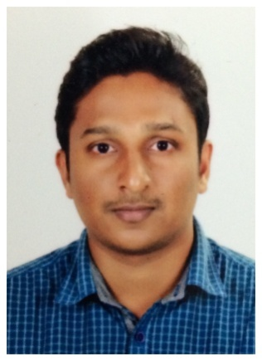

CAREER OBJECTIVE:
To find a challenging position to meet my competencies, capabilities, skills, education and experience.

EDUCATIONAL BACKGROUND:
❑ B.Com Specialized in co-operation
Calicut University, Calicut
❑ Plus two
JDT Islam Higher secondary school, Kozhikode.
❑ SSLC
Govt. NGO quarters High School, Kozhikode.

TECHNICAL SKILL:
- DIPLOMA IN INDIAN & FOREIGN ACCOUNTING (DIFA)
- Tally ERP
- MS OFFICE, Excel , POWER POINT
- MSCA

LANGUAGES:
ENGLISH, HINDI, MALAYALAM

EXPERIENCE:
- 1: 3 YEARS EXPERIENCE IN M/S INDUS MOTORS PVT LTD AS ACCOUNTANT.
Responsibility:
Maintaining Monthly reports, daily score cards, Incentive calculation.
Daily routine works like invoice receipt, petty cash details
Dealing with all bank statements
Calculation of service tax and VAT
- NOW WORKING IN M/S RAJASREE MOTORS PVT LTD (Dealer for Mercedes Benz Passenger Cars) AS ACCOUNTANT FROM 15.11.2014

Responsibility:
Maintain monthly reports subjected to both sales and service.
Maintain invoice tracker, cash receipts, petty cash flow.
Deals with all vendor payments.
Provide tracks of outstanding payments and follow up to concern department.
Calculation of service tax and VAT

PERSONAL DETAILS:
FATHER’S NAME - Pradeesh Kumar.C
MOTHER’S NAME - Hemalatha C
DOB - 20/02/1989
GENDER - MALE
RELIGION - HINDU
MARITAL STATUS - MARRIED
NATIONALITY - INDIAN
PERMANENT ADDRESS - Cholappurath Latha Nivas
Marikunnu. PO
Calicut-673012
CONTACT NO - 9847510275
E-MAIL - ronithcp@gmail.com

DECLARATION:
I hereby declare that all information given above are accurate and to the best of my knowledge for which I shall be solely responsible for any consequences.
Ronith.c

