CURRICULUM VITAE
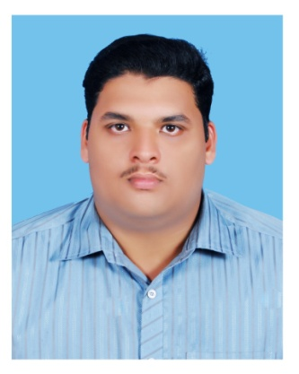

NIJITH ALUVANGAL
Aluvangal Madathil House E-mail : nijith5551@gmail.com
Perumanna (p.o) Mobile No : +91 9895275553
Calicut-673019

OBJECTIVES

To be associated with a leading and progressive organization which would give me the best opportunities to improve and utilize my skills and knowledge.

SYNOPSIS
- Is willing to do high level workloads with in strict deadlines.

WORK EXPERIENCE

- Working as REGISTRATION Dept & MIS INCHARGE at ADITHYA HONDA, Nadakavu, Kozhikode.
- Three Years of Working Experience as COMPUTER OPERATOR CUM CLERICAL STAFF at KDCA WELFARE CO -OPERATIVE SOCIETY LTD, Poovattuparamba,Calicut.

OTHER QUALIFICATIONS

- TALLY ERP 9
- DTP - Malayalam and English

ACHIEVEMENTS
- Experience in Automobiles, Banking, Financial and Software Sectors.
- Completed Internship in JAVA and PHP Programming from KELTRON, Calicut.
- Knowledge in Excel, C, C++ ,HTML, JAVA and SQL
- Got A+ grade in MS Office (Word, PowerPoint, Excel etc) From Akshaya- E-Centre, Perumanna.
- Got A+ grade in campus level Computer Eligibility Test conducted by MICT, Calicut.

EDUCATIONAL QUALIFICATION

S.No | Degree / Course | University / Board | Institution | Year of Passing
1. | MBA – Financial Management. | Madurai Kamaraj University | Saga Institute Of Management Studies, Calicut. | 2018
2. | Bachelor of Computer Application (BCA) | M.G.University | St.Joseph’s Devagiri Off campus centre for IT & Management studies, Calicut. | 2015
3. | Diploma in Electronics and Communication Engineering. | Board of Technical Examinations,  Govt. of Kerala. | AWH Polytechnic College, Calicut. | 2011
4. | Plus Two | Higher Secondary Board. | GHSS Kuttikkattoor, Calicut. | 2008
5. | S.S.L.C | Board of Public Education, Kerala. | ChinmayaVidyalaya,  Calicut. | 2006

PERSONAL INFORMATION
Name : Nijith Aluvangal
Date of birth : 11.05.1990
Father’s Name : Rajagopalan Aluvangal
Permanent Address : Aluvangal Madathil House,
Perumanna (Post),
Calicut -673019, Kerala.
E-mail address : nijith5551@gmail.com
Marital status : unmarried
Nationality : Indian
Religion : Hindu
Languages Known : English , Malayalam, Tamil.
Contact Number : +91 9895275553, +91 8129432115

Declaration

I do here by declare that the information furnished above is true and correct to the best of my
knowledge and belief.

Place : Calicut

Date: nijith aLUVANGAL

