Curriculum Vitae

**NAME : MANJUSHA . A** 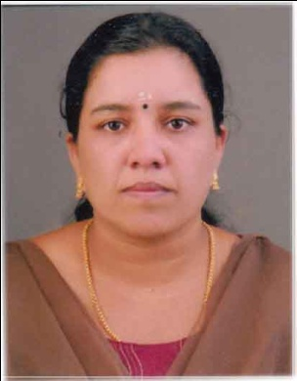

**ADDRESS : PEARL PARK**

**ODUMBRA**

**OLAVANNA (PO)**

**CALICUT**

**673 019( PIN)**

**FATHER’S NAME : SANKANARAYANAN NAIR**

**CONTACT NO : 9744961088**

**DATE OF BIRTH : 03/04/1977**

**SEX : FEMALE**

**MARITAL STATUS : MARRIED**

**RELIGION & CAST : HINDU, NAIR**

**NATIONALITY : INDIAN**

**EDUCATIONAL QUALIFICATION : S.S.L.C, PREE DEGREE**

**LANGUAGES KNOWN : MALAYALAM, ENGLISH**

### Experience :

* **Working as a HR Asst – KTC Group,(Mahindra) Calicut. {8 years}**

### Role and responsibility

* **Salary , ESIC, PF and incentive works**
* **record attendance and checking attendance register**
* **salary increment**
* **preparing various MIS**

***Declaration***

**I hereby declare that all the particulars mentioned above are correct and complete to the best of my knowledge and belief.**

**Place: CALICUT**

**Date: 10-01-2019 MANJUSHA .A**