***BIODATA***

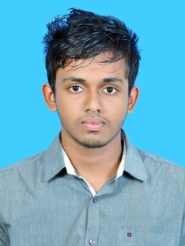***AJUL.P***

Puthiyarambath house

Kottooli (PO)

Kozhikode- 673016

Ph :9746820237

pajul96@yahoo,com

**PERSONAL PROFILE**

Father Name : Ajay Kumar.P

Date of Birth  :  26/11/1996

Religion  & Caste   : Hindu,Thiyya

Marital Status : Single

Nationality   :     Indian

Sex : Male

Communication Language    :    Malayalam, English

**Educational Qualification:**

➢  S S LC

➢ Plus two

➢ B.Tech In Mechanical Engineering (2018)

**Personal Skills;**

Self Confidence, Positive Attitude, Interested to learn New Things,Good Communication Skill,Good Interpersonal Skill,Willingness to Working Group,Abilitie to Lead Group Activities

**Computer Skills:**

➢MS Office

**Declaration**

I declare that above given facts are true to the best of my knowledge &belief.

Your’s faithfully

Place: Kozhikode

Date :  ***AJUL.P***