*RESUME*

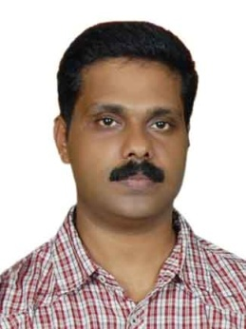

Mr.Reju George

“ PUNNYAM”

B37- Vrindavan colony.

Chevayur.PO,Calicut.

9400058793

**About me**

***Myself having 18 years of experience in sales &Marketing since 1998 like Uni Lever, ITC Limited, Honda Two wheelers & Honda Cars. My goal is not only to make volumes but also to create a delight experiences to whoever enter our premises to buy, exchange, test ride or any other service. Our customers may be a concern looking for the best suitable products for their requirements to meet individual needs with purposeful, simple, focused and fast processes. We should always try to make them happy with our available range of products and services by our smart approach and attitude.***

***I recognise that it is my onerous responsibility to show abundant caution in day to day activities for sales, marketing, After sales, Admin and inventory management.***

**Professional experience**

**\*Experience as a Manager (Sales , Marketing &Admin) in M/s Malabar Distributors, Calicut,Nadapuram, Vatakara & Thamarassery . (Distributors of Uni Lever& ITC LIMITED) (1998-2009)**

**\*Experience as Senior Manager(Sales& Marketing) in ADITHYA HONDA, Calicut ( Honda Motorcycles& Scooters India Ltd.) (2009-2015)**

**\* Experience as Sales Head in Vision Honda,Calicut (Honda Cars India Ltd) (2015-2016)**

**\* Currently working as General Manager - Nikkoy Honda, Calicut ( Honda Motorcycles &Scooters India Ltd).**

**Professional qualifications**

**Automobile Engineering (As a vocational subject of VHSE) 1987-1989**

**Graduation from Calicut University.**

**Declaration**

**I hereby declare that all the above mentioned information are true and correct to the best of my knowledge and belief.**

**Place: Calicut Yours sincerely**

**Date: 01-03-2019 Reju. George**