**CURRICULUM VITAE**

**SHIBIN BALAKRISHNAN** 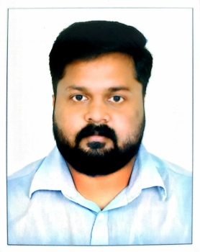

**KORACHAM KANDY (H)**

**KATALOOR (PO)**

**KOYILANDY (via)**

**KOZHIKKODE , KERALA , INDIA**

**PIN 673529, KERALA**

**MOB: +971-565848617 , +91 9645337299 Email:** [**shibinnandi@gmail.com**](mailto:shibinnandi@gmail.com)

***CAREER OBJECTIVE:***

Aspiring for a promising, challenging and motivating career in a suitable organization where in my Skills, Knowledge, Hard work would be assets and to make my Country, Institution, and my Family proud.

***EDUCATIONAL ATTAINMENT:***

|  |  |
| --- | --- |
| **NAME OF THE COURSE** | **INSTITUTE** |
| **MECHANICAL ENGINEERING DIPLOMA** | **AWH POLYTECHNIC COLLAGE KUTTIKKATTOOR,**  **KOZHIKKODE , KERALA** |
| **PLUS TWO**  **( SCIENCE )** | **ILAHIYA H S S KAPPADU , KOZHIKKODE**  **KERALA** |
| **SSLC** | **PAYYOLI G V H S S , KOZHIKKODE , KERALA** |

***PROFESSIONAL EXPERIENCES***

* 1 year 6 months experience as a service advisor in Bajaj two wheeler workshop Vatakara , Kozhikode , KERALA (2012-2013)
* 6 months experience in body shop service advisor in popular vehicles , maruti dealership Kozhikode.(2013-2014)
* 6 month experience as a service advisor in Nissan cars , E V M Nissan dealership Kozhikode , KERALA (2014)

(Front office work like job card opening, billing and customer dealing with floor managing)

**Currently working as a service advisor in AL ARABIA AUTO SERVICE in DUBAI. (2015 June to present)**

***ADDITIONAL QUALIFICATION:***

* Knowledge in Microsoft Office Tools & Computer operations.
* Language known in Malayalam, English, Hindi and Tamil.
* Hold light motor vehicle license in INDIA in last 10 years (2007 to present)

***PERSONAL DATA:***

Name : SHIBIN BALAKRISHNAN

Father’s Name : BALAKRISHNAN M

Date of Birth : 17/02/1991

Religion : Hindu

Marital Status : Married

Nationality : Indian

**DECLARATION**

I Mr. SHIBIN hereby submit this Curriculum Vitae for your kind consideration and for favorable orders. I assure you Sir/madam, if I am selected, I will deliver my duties to the entire satisfaction of my superiors. I declare that the information furnished above is true to the best of my knowledge.

Place: KOZHIKKODE

Date: 17-02-2020. SHIBIN BALAKRISHNAN