**SIDHARTH PS**

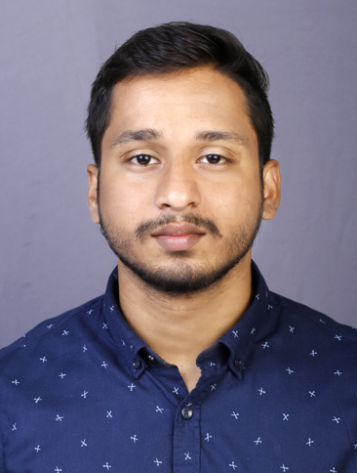

BACHELOR OF BUSINESS ADMINISTRATION

KOZHIKODE, KERALA| +919446610357 | [sidharthkarayil93@gmail.com](mailto:sidharthkarayil93@gmail.com)



**OBJECTIVE** **SKILLS**



To obtain a challenging position in forward looking companies for utilizing my skills and abilities that offers professional growth while being resourceful, innovative and flexible. I want to be creative, learning and contributing towards the success of the company

**WORK EXPOSURE**



Good work exposure in handling accounts of any type of business organization from vouching to preparation of final account. Experience in handling tax affairs and knowledge in preparation and e-filing of tax return. Knowledge in modern computer accounting software.

**WORK EXPERIENCE**



**Designation: Relationship Executive**

**Duration: Presently working (May 2019 onwards)**

**Organization: Shriram Transport Finance Company, Perambra**

Did all the functional aspects of

* Lending
* Recovery
* Credit
* Documentation

**Designation: Accountant**

**Duration: May 2018- May 2019**

**Organization: Electro Technical Institute, Perambra**

Earned experience in

* Preparation Of final accounts
* E-filing

**PROJECT**

**Effectiveness of online advertising**

Tally ERP 9.0

Sage 50

Quick Book Accounting

**APPLICATIONS**

Microsoft Office Suite: Word, Excel, PowerPoint.



**ADDRESS**



SREEPARNAM(H0)

K KARAYIL MEETHAL PERAMBRA(PO)

KOZHIKODE(DT)

PIN:673525

KERALA

**EDUCATION** **PERSONAL INFO**



|  |  |
| --- | --- |
| **BBA (FINANCE) Darunnujoom College of Arts and Science, Perambra**  **(Calicut University)** |  |
|  |  |
|  |  |
|  | |

**OTHER QUALIFICATIONS**



Diploma in Business Accounting and Management

**DECLARATION**

I hereby declare that the details furnished above are true to the best of my knowledge and belief.

**SIDHARTH PS**

**DOB:** 13-02-1998

**Nationality:** Indian

**Marital status:** Single

**Religion:** Hindu

**LANGUAGES KNOWN**



ENGLISH Read, Write, Speak

MALAYALAM Read, Write, Speak

TAMIL Speak



**STRENGTHS**



* Strong analytical
* Quick learner
* In-depth knowledge
* Effective communication and interpersonal skills
* Task oriented
* Keen observer