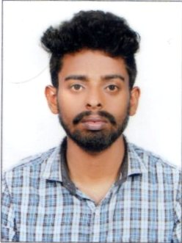
Resume
ASWANTH.S

Punnathum kandy house
ulliyeri (po)
mundoth
koyilandy (VIA)
kozhikode
KERALA,india
PIN- 673323
MOB : +91 9048332467, 7034221554
Email ID : aswanthsudhanpk@gmail.com

Career Objective:

To work in a creative and challenging environment whereby I can take part in the growth of the organization by applying my abilities to the best and for upgrading my skills and knowledge.

Personal Details:

Father’s Name : Sudhakaran .P.K
Date of Birth : 08 March 1994
Religion : Hindu
Marital Status : Single
Nationality : Indian
Mother Tongue : Malayalam

Educational Qualifications:

Qualification | Board/University
SSLC | Board of Public Exams , Kerala
Plus Two | HSE Kerala
ITI Process Control Instrumentation | MITI Calicut
Diploma in Instrumentation Engineering | KMCT Polytechnic College Kallanthode Calicut

Languages Known
- English, Malayalam, Hindi
Declaration:

I here by declare that the information specified above are true and correct to the best of my knowledge and belief.
Place: Ulliyeri ASWANTH.S
Date:

