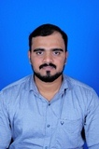 ***CURRICULUM VITAE***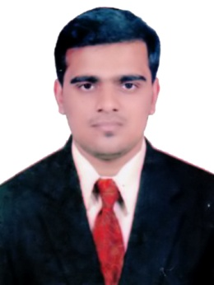

MUHAMMED MUNEES P

Mob : +971-555526787

E-mail : muneespallippuram@gmail.com

**Objective**

**Contribute to a dynamic growing organization where my strong analytical, interpersonal skills and hard work will have a significant impact. The optimal position will provide professional growth and opportunities to contribute.**

**Personal Strength/ Skills**

* **Good Communication Skill**
* **Honest, Sincere and Hardworking**
* **Ability to learn fast**
* **Listening to and following directions**
* **Ability to work independently**
* **Identify problem and provide solutions**
* **Interpersonal Skills**
* **Ability to work with others**

**Flexible and Adaptable**

**Educational Qualification**

|  |  |  |  |
| --- | --- | --- | --- |
| **Course** | **Board/ University** | **Percentage** | **Year of Passing** |
| B.com (Co-Operation) | University of Calicut | 65 | 2013 |
| Plus Two (Commerce) | HSE Kerala | 70 | 2010 |
| SSLC | Public Examination Board, Kerala | 70 | 2008 |

**Computer Knowledge**

* **Operating System Windows**
* **Microsoft Office (Word, Excel, Power Point)**
* **Tally**

**Technical Skills**

* **English Typing**
* **Arabic Typing**

**Work Experience**

**• one year private driver Abudhabi**

**Personal Details**

**Family Name : Pallippuram**

**Father’s Name : Majeed Pallippuram**

**Date of Birth : 30-04-1993**

**Religion : Islam**

**Nationality : Indian**

**Marital Status : Single**

**Language’s known : Arabic, English, Malayalam and Hindi**

**Uae Driving License Details**

* **Driving License No: 2397627**
* **Date of Issue : 04-10-2017**
* **Expiry date : 03-10-2019**
* **Place of Issue : Abu Dhabi**

**• Permitted vehicle : Light Vehicle**

**Declaration**

**I hereby declare that all above information are true and correct the best of my knowledge and belief.**

**Place: Abu Dhabi Sincerely,**

**Date: Muhammed Munees**