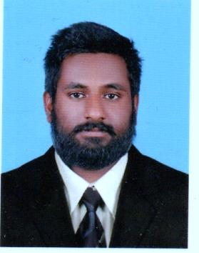

**ADDRESS**

Karakkulayan house

Pariyaram post

Kalpetta north

Pin 673122

**EMAIL**

[nfz143@gmail.com](mailto:nfz143@gmail.com)

**MOB**

9744774212

**LINKEDIN**

https://www.linkedin.com/in/noorul-faiz-k-52bb9a160

**NATIONALITY**

Indian

**LANGUAGES KNOWN**

English

Hindi

Arabic

Tamil

NOORUL FAIZ K

**MECHANICAL ENGINEER**

**FRESHER**

**EDUCATIONAL QUALIFICATION**

* **SSLC**

Completed in 2009

Percentage : 83

* **PLUS TWO**

Completed in 2011

Percentage : 73

* **DIPLOMA IN MECHANICAL ENGINEERING**

Completed in 2015

CGPA : 6.5

**SKILLS**

* Skilled knowledge in AUTOCAD
* SOLID WORKS.
* Microsoft office.
* Skilled in Automobile maintenance.

**QUALITIES**

* Good leadership.
* Works in any difficult condition.
* Hard working to achieve goals.

**HOBBIES**

* Cycling.
* Driving.
* Soccer