**CURRICULUM VITAE**

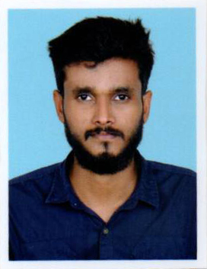

**SAYOOJ.A.P**

Athrappulikkal House

Vallikkunnu

Kadalundi P.O

Malappuram Dist

Pin:673 302

E-Mail: sayoojap1994@gmail.com

Contact No. +91 9895876516 , 8547516798

# CAREER OBJECTIVE

To pursue a highly challenging and creative career, where I can apply my existing knowledge and creativity, acquire new skills, and contribute effectively to the organization.

# PERSONAL DETAILS

Father’s Name : Sahadevan.A.P

Mother’s Name : Sheeja.A.P

Date of Birth : 27/12/1994

Sex : Male

Religion and Caste : Hindu, Thiyya

Nationality : Indian

Place of Birth : Kadalundi

Marital Status : Single

Languages Known : Malayalam ,English,Tamil

Hobbies : Reading, Listening Music, Sports

Blood Group : B +ve

# ACADEMIC PROFILE

|  |  |  |
| --- | --- | --- |
| **Name of exam** | **Year of Passing** | **Board/**  **University** |
| Degree  BBA | 2017 | Calicut university |
| Post Graduate Diploma in Business Accounting and Management(PGDBAM) | 2015 | Institute of Professional Accounting  (IPA) |
| +2 | 2012 | Board Of Higher Secondary  Examination, Kerala |
| S.S.L.C | 2010 | Board of Public Examinations, Kerala |

# COMPUTER KNOWLEDGE

* SAP B-One Consultant
* MS Office Package
* Tally ERP 9

**PERSONAL SKILLS**

* Leadership quality
* Hard working
* Positive thinking
* Confidence
* Sincerity towards work
* Thorough Knowledge in Accounting

# EXPERIENCE

* Seven months experience as a Accountant in AGTE, Calicut.
* Six month experience as a Accountant in Steel Mart, Calicut.

**DECLARATION**

I hereby declare that all statements made in this application are true and correct to the best of my knowledge and belief. I assure that, if I get a chance to work in your esteemed organization, I will be true to the rules and regulations of the concern.

Place : Vallikkunnu

Date : **SAYOOJ.A.P**