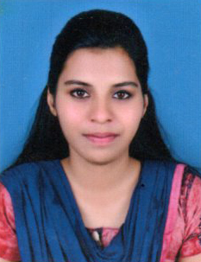
RESUME

INDHIRA MOHAN

Thadathil House

Pulpally post
Pulpally
Wayanad(Dist), Kerala
Pin - 673 579
Phone: +917907477710

Personal Profile:

Date of birth : 03/08/1998
Age : 21yrs
Sex : Female
Marital Status : Single
Nationality : Indian
Religion : Hindu
Father’s Name : Mohan T C
Languages Known : Malayalam,Hindi & English
Educational Qualification:

- B.Com (Perusing)
- CA Intermediate (Perusing)
- CPT
- HSE - Kerala Higher Secondary Examination Board
- SSLC - Kerala Public Examination Board
Extra curricular Activities

- Scout and Guides
- NSS ( National Service Scheme)

Declaration:

I hereby declare that all statement made this application are true and correct to the best of my knowledge and belief.

Place : Pulpally Yours Sincerely
Date :

