# RESUME

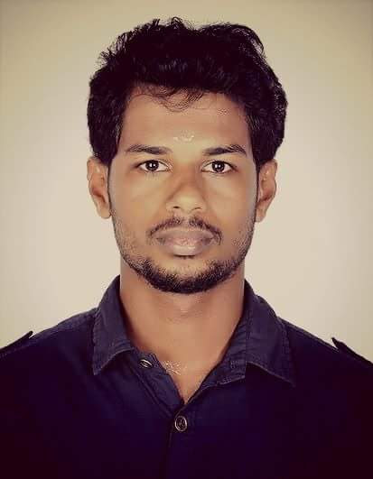

**Sreenu N C**

Nayadikunnath

“Sreekovil”

Manjyakad

Shornur 679121 Email Id: sreenunc90@gmail.com

Phone: 9746569824

### Objectives

* To pursue a professionally satisfying growth and challenging career. Seeking a quality environment where my knowledge can be shared and enriched for the growth of the organization and self.

### Summary of Experience

* Possessing one and half years of vast experience in the field of Computer Hardware & Networking where Planning, Implementation, Administration and troubleshooting are involved with multiple platforms of OS viz., Microsoft Windows XP, 2003, 2008, Windows 7.

### Expertise

* Provides one-on-one end-user problem resolution over the phone for user approved Personal Computer (PC) software.
* Diagnoses and resolves end-user network or local printer problems, PC hardware problems and mainframe, e-mail, Internet, WLAN and local-area network access problems.
* Able to provide a full range of support and client relationship services ranging from first through to third line support and customer on-site visits.
* Helps install local area network cabling systems and equipment such as network interface cards

### Work Experience

***Company:******POPULAR MOTOR CORPORATION from 16 JULY 2015 till 03 JANUARY 2020 .***

***Team size* : 20**

**Designation:** **System Administrator**.

**Job Responsibilities**

* Administrating and troubleshooting 2003 server (workgroup model).
* Managing user accounts and giving share & security level permissions.
* Responsible to install, set up, maintain network and also configure the peripherals, cabling and equipments accordingly as per the requirement.
* Responsible to monitor whether all the components are available for successful communication.
* Responsible for maintaining the Backup network, hardware, software, files on a regular basis accordingly as per the company policies.
* Responsible for the maintenance of UPS and CCTV .
* Managing data base of server & creating new users accounts.
* Responsible for configuring & troubleshooting NETGEAR & CISCO ROUTER.
* Responsible for configuring & troubleshooting Microsoft outlook accounts.
* Responsible for creating new Microsoft outlook accounts for new users.
* Monitoring complete network & providing network statistics.
* Responsible for the installation of all types operating system windows.
* Responsible for the installation of software’s like antivirus, MS-office, adobe & acrobat reader etc.
* Responsible for maintaining the network & troubleshooting the network related issues.
* Responsible for maintaining & troubleshooting network printers.
* Responsible for troubleshooting Internet issues.
* Responsible for sharing the network printers.

### Academic Qualification

***Academic:***

* **XII**  from TRKHSS VANIYAMKULAM in 2011.
* **CCNA and MCSE** from Inet Infotech Kochi.

***Technical Skills:***

* **Certification from Govt polytechnic in Network Engineering**
* Windows 2000, XP, Server 2003, 2008, 7.
* Ms office excel, word, powerpoint, Hardware & networking etc.,
* Good at Presentation & Communication skills.

### Assets

* Hardworking, Self confident, meets deadlines on task entrusted and ample analyzing capacity.

### Hobbies

* Football and caroms.
* Reading Books.

### Personal Information

Material status : Single.

Date of Birth : 14-12-1990

Languages Known : Malayalm, English, Tamil, Hindi and Kannada

### Declaration

I hereby declare that the above information furnished is true to the best of my knowledge and belief.

- Sreenu N C