**AMAL MC**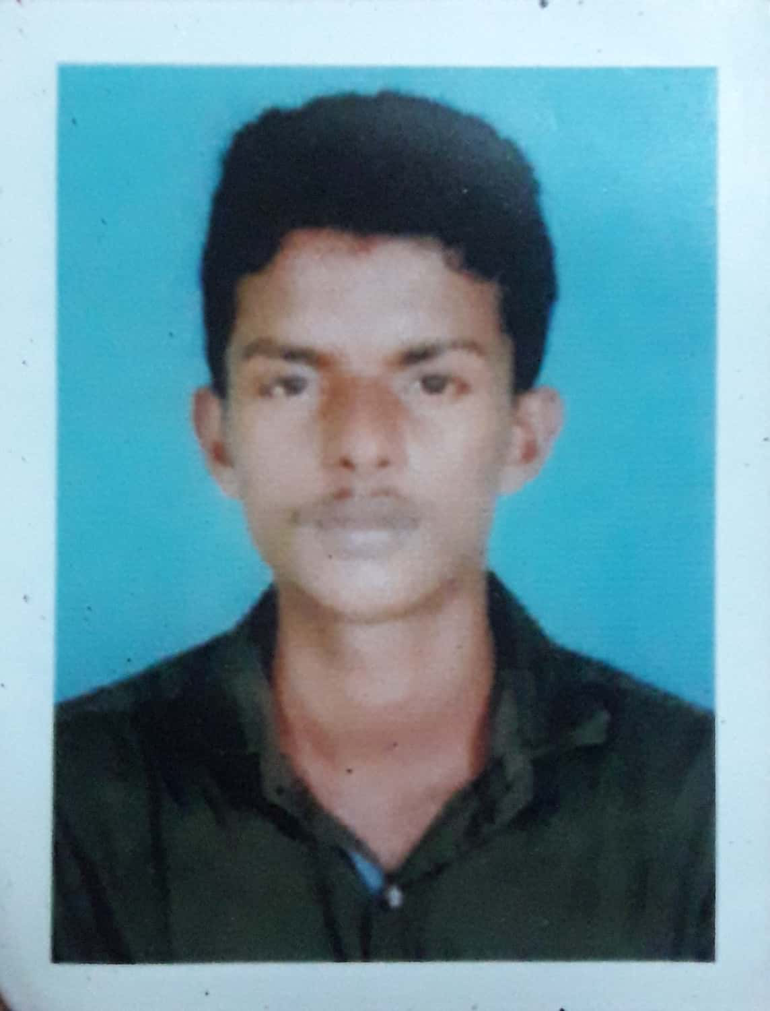

**B.E(MECHANICAL)**

**Contact No.:-**9497033231,9497043231

**E-mail:-**amalmc03@gmail.com

**Present Address:**

Gokulam(H)

Madathil Thodi ,Mankave (Po)

Calicut-673007

Kerala



**OBJECTIVE**

To work with maximum potential in a challenging and dynamic environment with an opportunity of working with diverse group of people and enhancing my professional skills with learning and experience in career growth.

**EDUCATIONAL QUALIFICATION**

|  |  |  |  |  |
| --- | --- | --- | --- | --- |
| QUALIFICATION | NAME OF THE  INSTITUTION | NAME OF THE  UNIVERSITY/  BOARD | YEAR OF  PASSING | PERCENTAGE/  CGPA |
| B.E  (MECHANICAL) | RVS Technical  Campus,  Kumarankottam,  Kannampalayam,  Coimbatore 641402 | Anna University  Chennai 600025 | 2019 | 6.9 |
| HSC | JDT Islamic Iqraa Higher Secondary School,Calicut,Kerala | Board of Higher  Secondary Education,Kerala | March-2015 | 73 |
| SSLC | Ganapath Boys High School ,Calicut ,Kerala | Board of Secondary Education,  Kerala | APRIL-2013 | 79 |

**SOFTWARE SKILL**

* MS word
* CAD
* CREO

**WORKSHOP ATTENDED**

* IMPT at “**steel & industrial forging LTD**”(Govt. of Kerala)
* One day work shop on “**FANUC ROBOTICS**”
* ONE Work shop on “**ADVANCED AUTOMOTIVE TRAINING**”

**CO-/EXTRA –CURRICULAR ACTIVITIES**

* Organized Technical Symposium at RVS Technical Campus as a Coordinator

**PERSONAL DETAILS**

* **Father’s Name** **:-** LOKESAN. MC
* **Mother’s Name :-** SHEEBA. P
* **Date of Birth**  **:-** 12 JULY 1997
* **Language Known** **:-** English & Malayalam
* **Marital Status**  **:-** Single
* **Nationality/Religion** **:-** Indian
* **Blood Group** **:-** O+VE
* **Permanent Address :-** Gokulam(H)

Madathil thodi, Mankave (PO)

Calicut,Kerala-673007

**DECLARATION**

I hereby declare that all the above mentioned information in this resume are correct to best of belief and knowledge.

**Place:**  Kozhikode  **AMAL MC**

**Date:** 20.08.2019  **(Signature)**